**Name: Tran Truong Quoc Bao( Iso) Student ID: N01625416**

**Date: 26/07/2024 Course ID: CPAN-131**

**Assignment 4 - Planet (5%)**

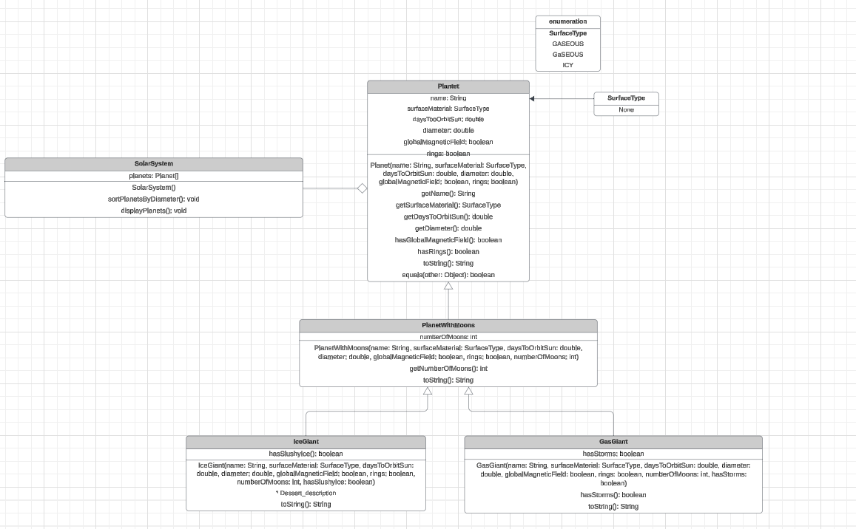

For the UML diagram, I also draw a relationship between them.

**Inheritance:**

Planet is the base class.

PlanetWithMoons is extended from ( which is ‘inherit’) Planet, adding the numberOfMoons attribute.

IceGiant and GasGiant are extended from( which is ‘inherit’) PlanetWithMoons, adding their specific attributes (like the hasSlushyIce and hasStorms).

**Polymorphism:**

I demonstrated the SolarSystem class where it handles different types of Planet objects (including PlanetWithMoons, IceGiant, and GasGiant) through a common interface.

The toString() method is overridden in each subclass to include specific details, and the superclass toString() method is called using super.toString().

**Aggregation:**

SolarSystem aggregates an array of Planet objects, managing multiple instances but not owning them in a strict sense.(array like Mars, Earth and so on)